**Calibrating in Proteoform Suite**

1. Under Load Options, select the button Chemical Calibration

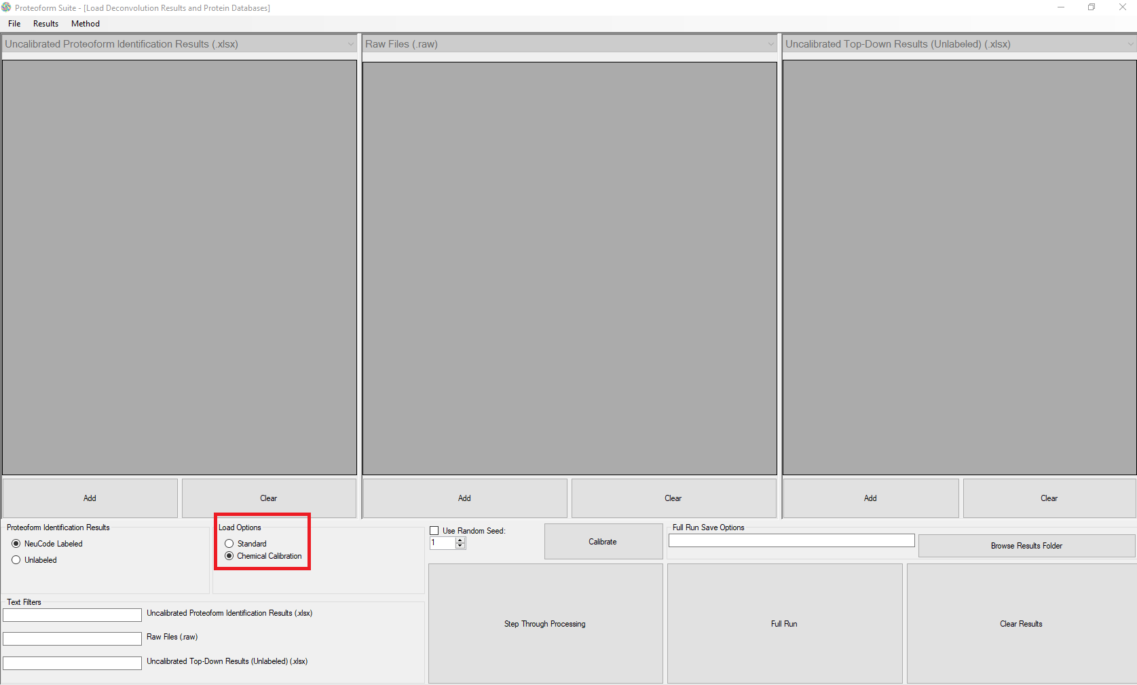

1. Click the Add button under the left grid view for “Uncalibrated Proteoform Identification Results (.xlsx)”. Select all .xlsx files in the folder uncalibrated_identification_files.
2. Click the Add button under the middle grid view for “Raw Files (.raw)”. Select all raw files. For this example dataset, these are publicly available on the MassIVE platform (MSV000081592, ftp://massive.ucsd.edu/MSV000081592).
3. Click the Add button under the right grid view for “Uncalibrated Top-Down Results (.xlsx)”. Add the file B7A_hits_5%FDR.xlsx.
4. Under the file menu Method, select Load Method.

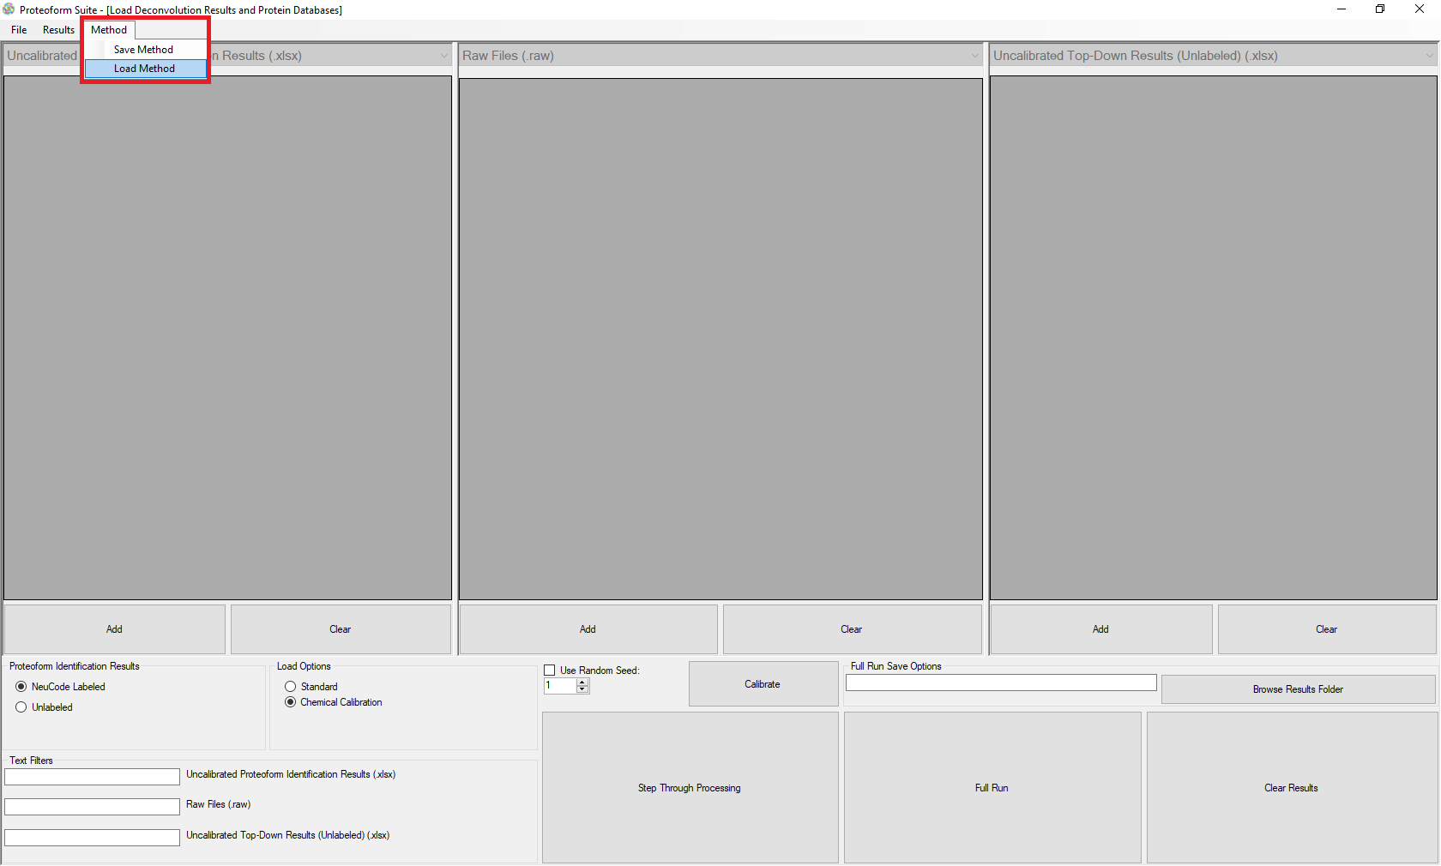

1. Select the method loaded in this folder called “Calibration_ProteoformSuite_example_method.xml”
2. A message box will ask “Add files at the listed path if they still exist?” Select No.
3. The files in the Uncalibrated Proteoform Identification Results and Raw Files grid views should now all be labeled with biological replicate, technical replicate, and fraction. If you load in different files from those listed in the method .xml file, you will need to click the row and edit these labels.

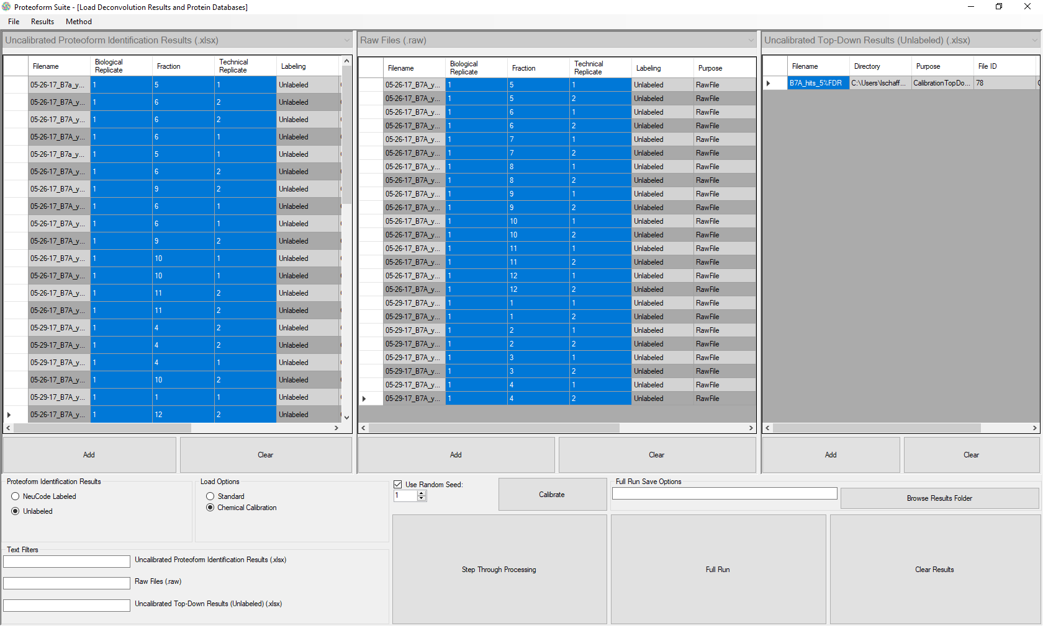

1. Now we need to load in a theoretical database. Under the file menu Results select Theoretical Proteoform Database.

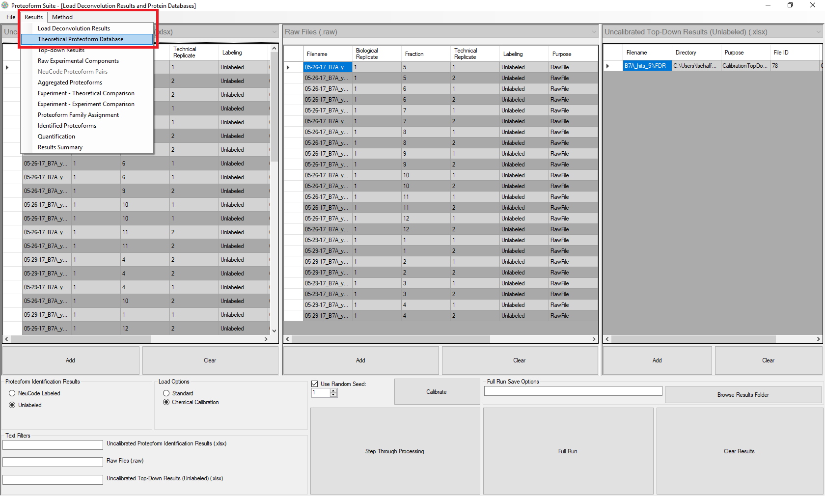

1. Click the Add button, and add all files in the folder proteoform_databases_yeast.
2. Click the button at the bottom “Time to make the databases”.
3. On the file menu Results, go back to Load Deconvolution Results.
4. Click the button “Calibrate.” The software will now run.

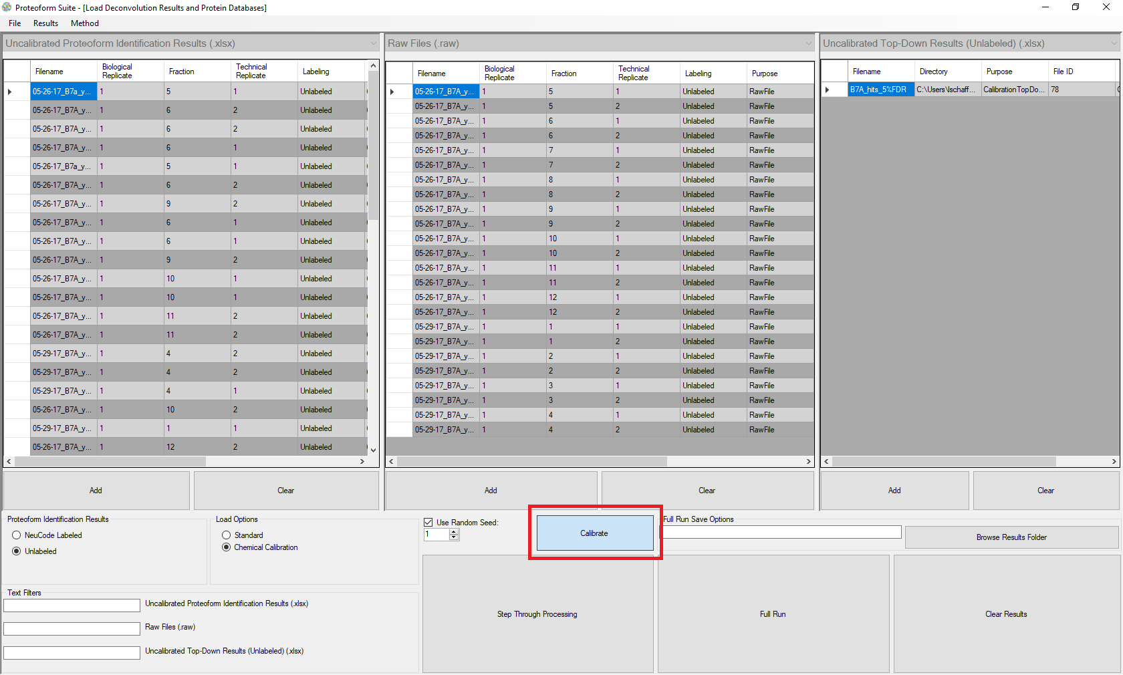

1. When the process is complete, a message box will show. Calibrated excel files will automatically be written in the same location as the input files.